MHRA SPRING 2026
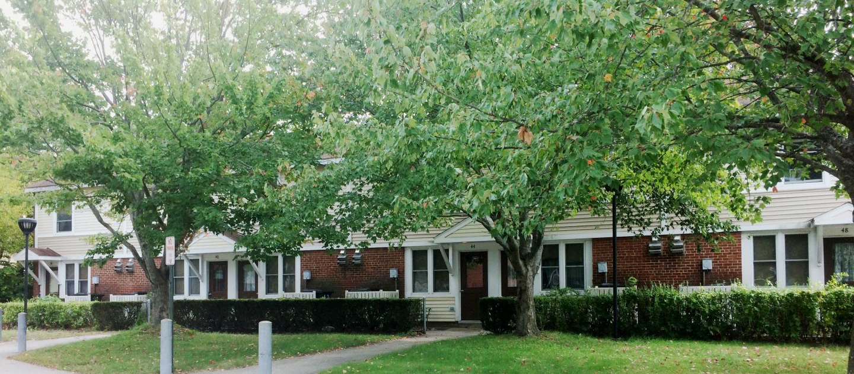
This newsletter is provided for informational purposes and is not a substitute for official notices or lease requirements.
In This Edition:  - Announcements & Office Updates  - Maintenance Corner  - Income & Recert Reminders  - Veteran Resources  - Summer Camp Resources  - Closing Messages | Welcome to the Spring 2026 MHRA Resident Newsletter. Our goal is to keep residents informed about important reminders, office updates, and helpful community resources. If there’s something you’d like to see included in future editions, let us know – this newsletter is for you.
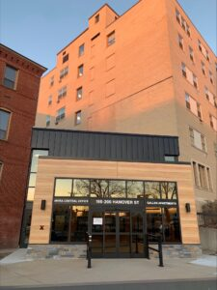  Main Office -198 Hanover St | CONTACT INFO  Main Office: 603-624-2100  www.manchesterhousing.org  Info@manchesterhousing.org  Work Orders: 603-624-2176  😁Did you know you can submit non-emergency work orders through your resident portal? If you need something fixed in your apartment or see something in need of repair on property, let us know!
Board of Commissioners Meetings
The Manchester Housing and Redevelopment Authority’s Board of Commissioners meets monthly on the third Tuesday at 12 noon in the MHRA Offices unless otherwise noted here. For more information, contact the MHRA Central Office at (603) 624-2100.
Upcoming dates MHRA offices are CLOSED…  Memorial Day – Monday, May 25  Juneteenth – Friday, June 19  Independence Day – Friday, July 3 | FSS NEWS  MHRA is pleased to announce that the Family Self-Sufficiency Program (FSS) is now the First Steps to Success Program to better reflect the benefit that it can be to those who join. The title change shows the power of the program. FSS can be one of your first steps in your hosting journey to help you reach your definition of success and self-sufficiency. All voucher holders and public housing residents are welcome and encouraged to ask for more information and fill out enrollment forms if interested.  Please contact: Kelsey at  KFuller@manchesterhousing.org  603-624-2183
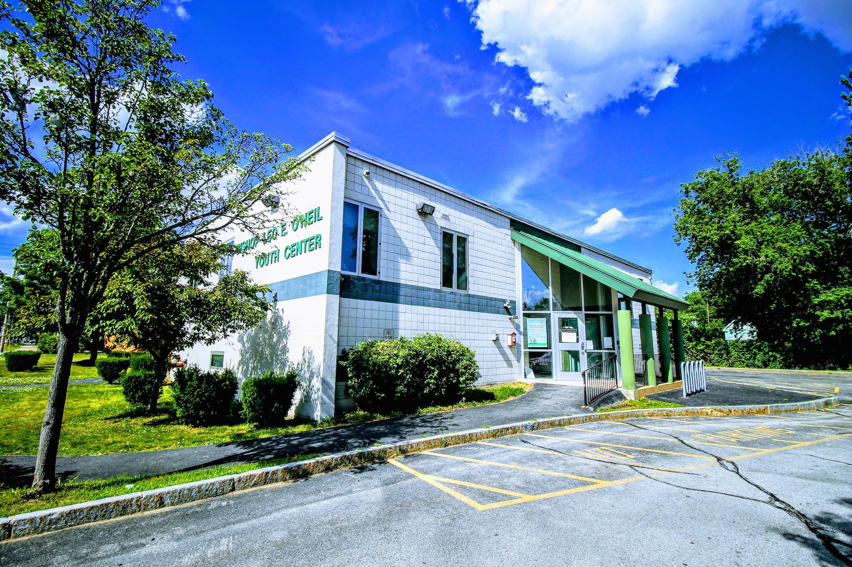
did you know?!
Our Bishop O’Neil Youth Center Gym is Available to Rent!
Looking for a large indoor space in the middle of Manchester? The gym at the Bishop O’Neil Center is available to rent for community use.
It may be a great option for:
- Cheer or dance teams needing indoor practice space
- Volleyball or rec sports
- Roller derby practice
- Exercise or fitness classes
- Club meetings or community groups
- Book clubs or organizations that have outgrown their usual space
The gym offers a large open area that can accommodate a variety of activities.

If you know a group or organization looking for space, the Bishop O’Neil Center may be a great option.

For rental information, visit www.manchesterhousing.org
Maintenance Corner  Call the central maintenance facility (CMF) for all repairs. Give your name, address, phone number and a brief description of request. Don’t wait to report small issues. Early repairs help prevent bigger problems.  Reminder:  - If you put in a work order request, minors must NOT be home alone and animals must be put away.  - Charges may apply for damage beyond normal wear and tear, in accordance with MHRA policy.  - Adhere to pest control treatment plans!  - Test smoke detectors and report concerns.  Maintenance Hours: M-F: 7am-3:30pm  Emergency repairs only: M-F: 3:30pm to 7am. Saturday & Sunday. |   Maintenance:  603-624-2176  Pest Control:  603-624-2120
A Message From Our Managing Director of Real Estate Development and Special Projects  What’s Going on at Kelley Falls?  In addition to the ongoing everyday work, there’s a new community center being built on the Kelley Falls campus at the corners of Kimball and Mason and Upland! It has been rising up since mid-year last year and opening is anticipated in the fall. Known as the Mark Stebbins Community Center, it will house a variety of collaborative nonprofit services and spaces for West End residents including the Boys & Girls Clubs of Greater Manchester, Amoskeag Health, and others providing access to child care, health care and more. For additional information, see www.markstebbinscommunitycenter.org and watch for its opening later this year!  Mary Ellen Jutras | Did you know 6,615 work orders were completed in 2025!  Thank you for reporting issues promptly – it helps us serve everyone better.

Important reminders from the property management team
Rent Payments: Due the 1st of the month, every month. After the 5th it is late. You may pay in person, by mail, or online through the resident portal (if enrolled).
Rent & Repayment Agreements are payable online through your portal!
ÜNote: payments through the portal have the following transaction fees-
📨 $2 for eCheck (ACH) payments (enter your account and routing numbers)
💳$9.95 for debit card payments (enter your debit card numbers)
💳3% fee for credit card transactions. As well as Paypal and Venmo.
The Resident Portal Can Help allows residents to save time, reduce trips to the office, help avoid missed deadlines.
→Upload documents →View balances →Submit Work Orders →Receive Notices electronically.
If you are not registered and would like to be, please contact your zone office.
Electric Bill Help  Some MHRA residents pay their own electricity bills for items such as lighting, appliances, and air conditioning. If you are responsible for your electric bill, you may qualify for assistance through the Electric Assistance Program (EAP).  The EAP provides a discount on monthly electric bills for income-eligible households.  How to Apply: applications for EAP are processed through the local Community Action Agency:  Southern New Hampshire Services (SNHS)  40 Pine St, Manchester  603-668-8010  www.snhs.org  Residents can contact SNHS directly to ask about eligibility and the application process.  MHRA Reminder: MHRA units include heat and hot water in the rent. The Electric Assistance Program only applies to electric bills paid directly by the resident.  If you have questions about utilities in your unit, contact your property management office. | Know Your Housing Team  MHRA staff are here to help. Knowing who to contact can help your request get resolved faster.  Public housing has the following 4 zone offices  Covering properties all over the city…  Elmwood Gardens: your Property Manager(PM) is New Hire April 20! and Assistant Property Manager(APM) is Jade Fauteux!  603-624-2163  Kelley Falls: Lexi Bessette is your PM & you also have New Hire as your APM, as well as Property Management Specialist -Lindsay DeCarli!  603-624-2160  Kalivas Hi-Rise: Amy Higginbottom is also your PM, Teresa Halibi the APM and Sarah Dionne as your PM Specialist!  603-  Burns Hi-Rise: Your PM is Lexi Bessette, with Carla Padilla as your APM, and Ben Atkinson as your PM Specialist!  603-623-6649

Quick Facts: Income, Jobs & Life Changes  Thinking about:  - Driving for Uber, Lyft, Doordash, or Instacart?  - Selling crafts on Etsy, Tedoo, or at local fairs?  - Starting a small business or side hustle?  You’re allowed to earn that money. We just need to know about it so your rent is calculated correctly.  👉 Tip: Self-employment income is counted after allowed business expenses – not just what you earn before costs.  If you’re unsure what counts, ask us first. We’re happy to explain.  📅 10-Day Rule  FACT: You must report changes in household income or size within 10 days of the change.  This includes:  - Starting or ending a job  - Changes in hours or pay  - Someone moving in or out  - Ending cash assistance or benefits through DHHS  When in doubt è report it. We’ll help figure out next steps. |  | Annuals vs. Interims – The Easy Version  FACT: Not every change means an immediate rent change.  - Annual Recertification: Happens once a year for everyone  - Interim Recertification: Happens only when needed during the year  📌 Sometimes, if a change happens close to your annual review, it may be handled at your annual instead – this can actually help avoid unnecessary paperwork or sudden changes.  👉 Always report changes on time – MHRA will determine how and when it’s processed.  Benefits & Assistance Changes  FACT: Some benefits (like cash assistance) may end when you start working – and that’s okay.  We’ll:  - Review your new income  - Update your file correctly  - Make sure your rent is based on accurate, verified information  No surprises. No guessing.  📢 Communication Helps You  FACT: Talking to MHRA early can prevent:  - Retroactive charges  - Delays  - Stress later on  We’re not here to “catch” anyone – we’re here to keep your file accurate and protect your housing.  🙂 Final Friendly Reminder: If something changes in your life and you’re unsure how it affects your housing…  📞 Call, 📧 email, or stop by. We’d much rather answer questions up front than fix problems later.

Support for Veterans
Manchester and the State of New Hampshire offer several programs to help veterans and their families with healthcare, housing, employment, and benefits navigation. If you or someone in your household served in the military, these organizations may be able to help.
 | Manchester Veterans Services Office  The Manchester Veterans Services Office helps veterans and their families access benefits and local support programs.  They can assist with:  - VA benefit applications  - Disability claims assistance  - Connecting veterans to housing and support programs  - Burial and survivor benefits  - Local veteran resources  📍Manchester City Hall  Manchesternh.gov (search veterans services)  📞 603-624-6510 |  | NH State Veterans Services  The New Hampshire Office of Veterans Services helps veterans and families understand and apply for benefits.  Support includes:  - Disability compensation assistance  - Pension benefits  - Survivor benefits  - Appeals support  Nh.gov/veterans  603-624-9230
 | 🏥Manchester VA Clinic  The Manchester VA Community Based Outpatient Clinic provides services such as:  - Primary care  - Mental health services  - Lab work and diagnostics  - Referrals for specialty care  📍718 Smyth Road, Manchester  Va.gov/health-care  📞 603-624-4366 |  | Housing Support for Veterans  Veterans who are experiencing housing instability may qualify for assistance through:  HUD-VASH Program- This program combines housing assistance with VA case management services for veterans experiencing homelessness.  Services may include:  - Rental assistance  - Supportive service  - Housing stability support  If you are a veteran or someone you know is a veteran in need of housing support, contact the VA or your MHRA property management office for guidance.
 | Veterans Count (Easterseals NH)  Financial assistance and support services for veterans and military families.  www.VeteransCount.org  NH Vet Center (Manchester)  Counseling services for veterans and their families.  📍1461 Hooksett Road  📞 603-668-7060 |  | ✨ Veteran Crisis Support  If you or a veteran you know needs immediate help:  Veterans Crisis Line: Dial 988 then press 1  Text: 838255  Veteranscrisisline.net  Support is available 24 hours a day.

Thank you for your service
MHRA appreciates the service and sacrifices made by veterans in our community.
If you are a veteran and need help navigating resources, your property management office may be able to connect you with local support services.
Thinking about summer camp?
Manchester Parks & Rec Programs
The City of Manchester offers summer camps, sports programs, and recreation activities for youth throughout the city. -baseball, basketball, disc golf, football, golf, ice hockey, ice skating, lacrosse, soccer, skiing, swimming & more.
Visit www.manchesternh.gov/Departments/Parks-and-Recreation/Programs-and-Activities
Fun in the sun registration link: https://manchesternh.recdesk.com/Community/Home

Other Programs
Boys & Girls Club of Manchester https://bgcgm.org/programs/summer_programs/
YMCA - https://www.graniteymca.org/camps/
NH Audubon Center - https://nhaudubon.org/education/nature-day-camp-2/summer-camp/
Many summer programs offer financial assistance or sliding scale fees. If cost is a concern, ask the organization about scholarship opportunities.
Summer programs fill up quickly, so registering early is encouraged.
Seasonal Safety Reminder – Spring
- As snow melts, please help keep walkways clear of debris
- Report Maintenance issues promptly
- Be cautious of wet or slippery surfaces
- Test smoke detectors and report concerns to maintenance
Directors Block
Before I go…

Closing out this newsletter with a moment from me – your first newsletter organizer, winging-it champion, fellow long-time resident, and one who shall remain unnamed (for now).
I wanted to take a moment to end this first issue with a bit of reflection and appreciation.
Our communities are made up of many different people, stories, and experiences. What we all share is the place we call home. Whether you’ve lived here for many years or are newer to the community, each resident plays a part in what makes our neighborhoods what they are.
This newsletter was created as a simple way to share helpful reminders, highlight resources, and keep residents informed about things happening across MHRA. My hope is that it becomes something useful – maybe even something you keep on the fridge for a little while.
Thank you to the residents and staff who help keep our communities running day-to-day. It takes more people than most realize.
And if this newsletter continues, I hope each issue brings a little information, a little clarity, and maybe the occasional helpful tip along the way.
-Until the next issue – assuming they let me make another one.
P.S. If you have thoughts about this newsletter – good, bad, or somewhere in between – feel free to send me note through your zone office or at 198 Hanover because…
- I don’t get much mail.
- I genuinely thrive on feedback.
- And honestly…content.

Now that the snow has melted, the impressive construction of the Mark Stebbins Community Center at Kelley Falls is fully visible. This is a truly remarkable partnership between MHRA and the Stebbins family—one we are incredibly proud to be part of.
The Community Center will be home to a Boys & Girls Club, Amoskeag Health, and many other resources, all within walking distance of the front doors of our Kelley Falls and Upland Heights residents.
The Center is scheduled to officially open this September, and we hope you’ll have the opportunity to stop by and experience this incredible space for yourself!
Shannon Wright
Executive Director

As we launch our first newsletter, I want to sincerely thank you for being a valued part of our community and for the pride you take in calling it home. Our team is committed to supporting residents and working every day to improve services, communication, and quality of life across our properties. This newsletter is one way we hope to stay connected, share important updates, and strengthen our sense of community. Another great way to improve communication is by signing up for the tenant portal, which allows you to receive updates, submit requests, and stay informed more easily. We also ask for your partnership in working with our maintenance staff to keep buildings and common areas clean, safe, and welcoming—when we care for our surroundings together, we create a place we can all be proud of. This is your home, and you belong here. We encourage you to reach out, report concerns, and participate in keeping our community a place we are proud to call home. Your feedback, ideas, and concerns matter, and help us continue to improve and grow together.
Marie Papineau
Housing Operations Director
Kris Erkkila
Assistant Director of Operations

